## LAB ASSSIGNMENT:1.4

## NAME:DHEVULAPALLY RASHMITHA

## ROLL_NO:2403A51432

## BRANCH:CSE

## TASK 1:

SREENSHOT:

## ai1.png

## TASK 2:

SCREENSHOT:

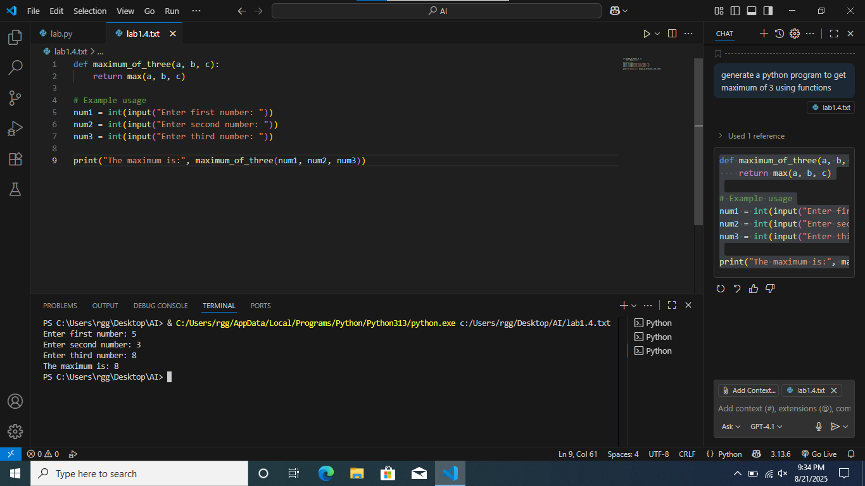

EXPLANATION:

The program defines a function maximum_of_two(a, b) that returns the larger of two numbers.

It takes two inputs from the user, calls the function, and prints the maximum

## TASK 3:

SCREENSHOT:

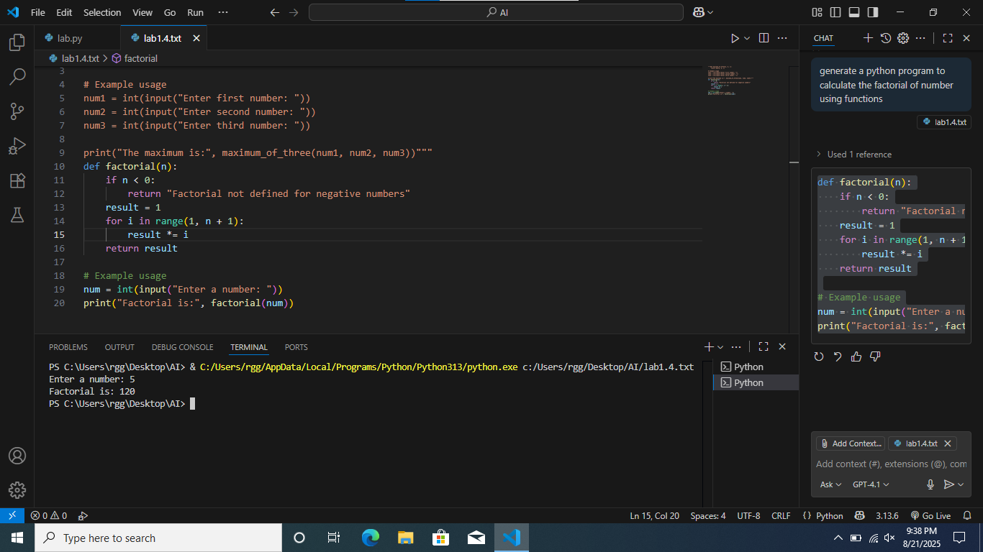

EXPLANATION:

This program defines a function factorial(n) that calculates the factorial of a number n using a loop.

It takes an integer input from the user and prints the factorial result.

If the input is negative, it returns a message saying factorial is not defined for negative numbers.

## TASK 4:

SCREENSHOT:



EXPLANATION:

This program defines a Student class with attributes for name, roll number, and marks.

It includes a method display_details() to print the student's details.

An example creates a student object and displays its information.

## TASK 5:

SCREENSHOT:

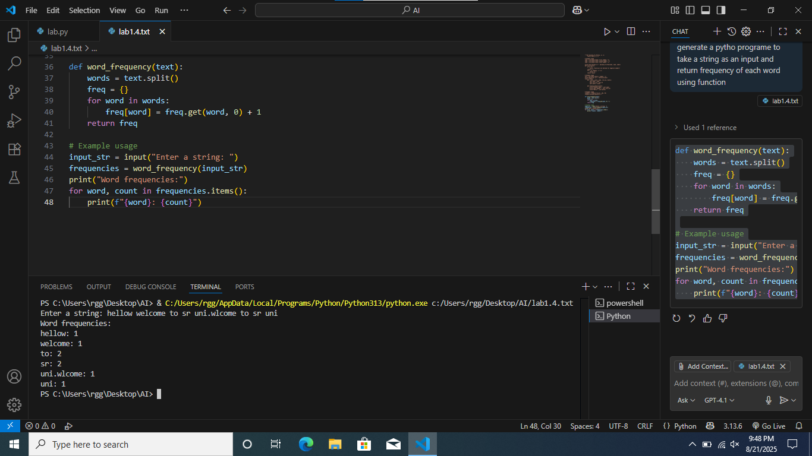

EXPLANATION:

This program defines a function word_frequency that counts how many times each word appears in a given string.

It takes a string input from the user, calculates word frequencies, and prints each word with its count.